Time series forecasting

Các thành phần của 1 chuỗi dữ liệu theo thời gian (time series)

1) Thành phần xu hướng (Trend)

* + A trend exists when there is a long-term increase or decrease in the data. There is a trend in the sales data shown below (Hyndman and Athanasopoulos 2014).

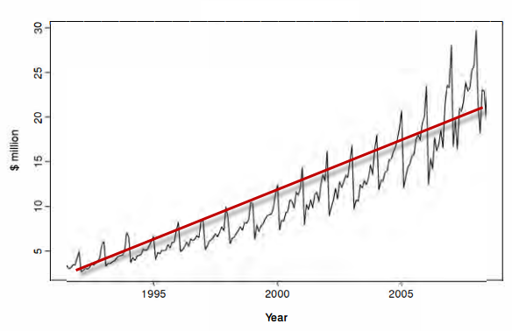

* + A seasonal pattern occurs when a time series is aﬀected by seasonal factors such as the time of the year or the day of the week. The monthly sales below show seasonality partly induced by the change in cost of the products at the end of the calendar year.

2) Thành phần mùa (Season)

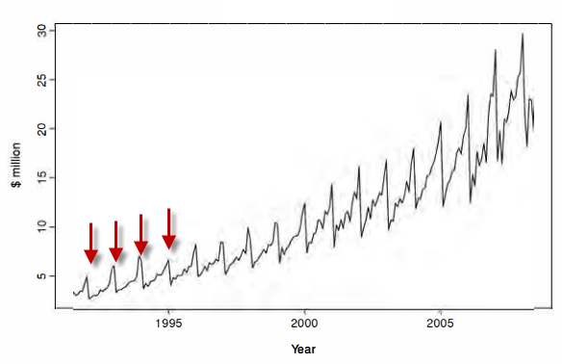

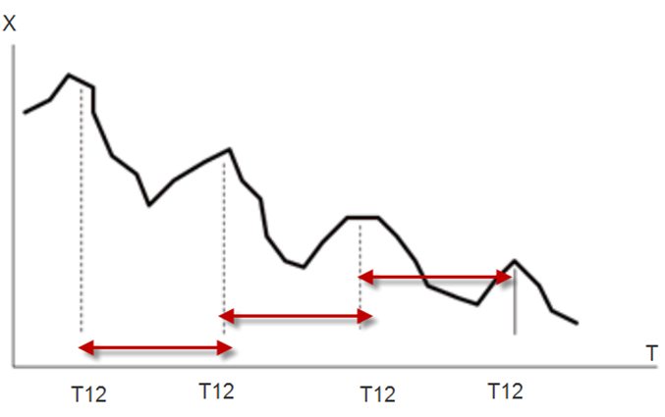

* We shall think of the time series *Yt* as comprising three components: a seasonal component, a trend-cycle component (containing both trend and cycle), and a remainder component (containing anything else in the time series).

Phân tích thành phần của 1 time series:

*Yt* = *Tt* + *St* + *Et*

Trong đó, Yt là giá trị của biến số (của TS).

**Tt là thành phần xu hướng (Trend)**

**St là thành phần mùa (Season)**

Et là thành phần ngẫu nhiên (Random)

Chúng ta kỳ vọng rằng Et nó sẽ là một số nhỏ (sát 0).

* Thus, a time series data at period *t* denoted *Yt* is expressed as:

*Yt* = *Tt* + *St* + *Et* (41)

* To decompose a time series containing both trend and season components, we perform the following steps:

Các bước phân tích một Time Series

Step 1: Constructing a simple linear regression model to extract the trend component (assuming that there is a linear relationship between time *t* and *Y*)

Bước 1: xây dựng 1 mô hình hồi quy đơn biến để phân tách thành phần xu hướng (Trend)

*YTrend* = *b*0 + *b*1*t* (42)

Trong đó, YTrend là thành phần xu hướng. b0 và b1 là 2 hệ số của MHHQ. *t* là thời điểm trong quá khứ.

Step 2: Computed the time series without the trend component as follows:

Bước 2: Loại bỏ thành phần xu hướng ra khỏi chuỗi dữ liệu:

*YS* = *Y* - *YTrend* (43)

YS = Thành phần mùa + Thành phần ngẫu nhiên

Do thành phần ngẫu nhiên được giả thiết ~ 0, xem YS = Thành phần mùa

Step 3: Compute the seasonal component by averaging *YS* at different time periods.

Bước 3: Tính hệ số (thành phần) mùa của chuỗi bằng cách lấy trung bình của YS tại các thời điểm khác nhau.

* To forecast a new data instance based on the result of decomposition process, we perform the following steps:

Để dự báo giá trị của TS tại 1 thời điểm trong tương lai thì ta làm các bước sau:

Step 1: Compute the trend component of the new data as follows:

Bước 1: Tính thành phần xu hướng:

*YTrend* = *b*0 + *b*1*tNew* (44)

Với tNew là 1 thời điểm trong tương lai.

Step 2: Compute the seasonal component of the new data as *S*(*tNew*)

Bước 2: Tính thành phần mùa tại thời điểm tNewđược ký hiệu là *S*(*tNew*)

Step 3: The final forecast is given by: *YtNew* = *YTrend* + *S*(*tNew*) (45)

Bước 3: Tính giá trị Y tại *tNew* theo: *YtNew* = *YTrend* + *S*(*tNew*)

Project Control and Monitoring

Project Control

**1. Earned Value Analysis**

* Earned value analysis (EVA) is an analysis technique that compares the actual schedule and cost to the performance measurement baseline. You can accomplish performance measurement analysis using a technique called **earned value management (EVM).**
* EVM compares what you’ve received or produced to what you’ve spent. The EVM continuously monitors the planned value, earned value, and actual costs expended to produce the work of the project.
* When variances that result in cost changes are discovered (including schedule variances and cost variances), those changes are managed using the project change control system. The primary function of this analysis technique is to determine and document the cause of the variance, to determine the impact of the variance, and to determine whether a corrective action should be implemented as a result.
* To perform the EVM calculations, you need to f rst gather the three measurements mentioned earlier: **the planned value** (**PV**), **actual cost** (**AC**), and **earned value** (**EV**).
* Planned Value: The planned value (PV) is the cost of work that has been budgeted for a schedule activity during a given time period. These budgets are established during the planning processes. For any given day, PV equals the planned cost of work that is scheduled to be completed on that day, whether or not the work is actually completed. **PV is also called budgeted cost of work scheduled (BCWS).**

Budgeted cost = chi phí theo kế hoạch

Work Scheduled = công việc theo kế hoạch

* Actual Cost: Actual cost (**AC**) is the actual cost of completing the work component in a given time period. Actual costs might include direct and indirect costs. Actual costs include whatever is spent to complete the work regardless of what was budgeted. **AC is also called Actual Cost of Work Performed (ACWP)**.

**Actual cost = chi phí thực tế**

**Work Performed = công việc đã thực hiện**

* Earned Value: Earned value (**EV**) is the value of the work completed to date as it compares to the authorized budgeted amount assigned to the work component. EV is typically expressed as a percentage of the work completed compared to the budget. For example, if our budgeted amount is $1,000 and we have completed 30 percent of the work so far, our EV is $300. Therefore, EV cannot exceed the PV budget for the activity. **EV is also called Budgeted Cost of Work Performed (BCWP).**
* In summary:

■ PV—The approved budget assigned to the work to be completed during a given time period (BCWS)

■ AC—Money that’s actually been expended during a given time period for completed work (ACWP)

■ EV—The value of the work completed to date compared to the budget (BCWP)

* EV is the sum of the cumulative budgeted costs for completed work for all activities that have been accomplished as of the measurement date. For example, if your total budget is $1,000 and 50 percent of the work has been completed as of the measurement date, your EV would equal $500.

**EV = 1000 x 50% = 500**

* You can plot all the PV, AC, and EV measurements graphically to show the variances between them. If there are no variances in the measurements, all the lines on the graph remain the same, which means the project is progressing as planned. The figure below shows an example that plots these three measurements. From this figure, PV = 400, EV = 375, and AC = 325.

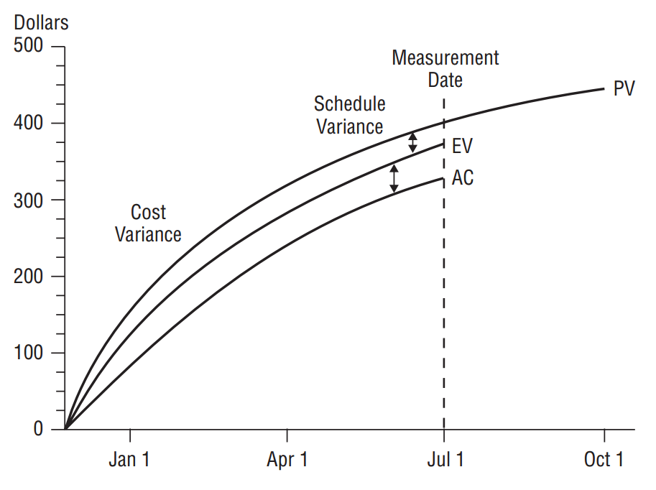

Figure 16. Earned value

**2. Cost Variance and Schedule Variance**

Các chỉ số dùng để kiểm soát chi phí và tiến độ

* Variance analysis examines the difference between the baseline cost or baseline schedule as they compare to actual performance, and/or the variance at completion of the project.
* **Cost variances** are determined by subtracting AC from EV:

CV = EV – AC (21)

If the cost variance is positive, your costs are under what was planned and you are doing better than expected. If they are negative, you are over what was planned.

Sai lệch về chi phí: CV = EV – AC

Nếu CV > 0 thì dự án có chi phí thực tế ít hơn so với ngân sách (hoạt động hiệu quả)

Và CV < 0

* **Schedule variances** are determined by subtracting PV from EV:

SV = EV – PV (22)

If the schedule variance is positive, you are ahead of schedule; if it is negative, you are behind schedule.

Sai lệch về tiến độ: SV = EV – PV

SV > 0 thì dự án có tiến độ nhanh hơn so với kế hoạch

SV < 0 …

* Let’s calculate the CV using the numbers from the figure above: 375 – 325 = 50. The CV is positive, which means you’re spending less than what you planned for the work that you have completed as of July 1.

SV = 375 – 400 = –2. The resulting schedule variance is negative, which means you are behind schedule, or behind where you planned to be as of July 1.

**3. Cost Performance Index and Schedule Performance Index**

* The **cost performance index (CPI)** measures the cost efficiency of the work completed against actual cost. The cost performance index (CPI) is calculated this way:

**CPI = EV / AC** (23)

If CPI is greater than 1, you’re spending less than anticipated to date. If CPI is less than 1, you are spending more than anticipated for the work completed and have a cost overrun on your hands.

Using the above example, CPI = 375 / 325 = 1.15 This means cost performance is better than expected.

Chỉ số hiệu suất chi phí: CPI = EV/AC

Nếu CPI > 1 thì dự án có chi phí ít hơn so với kế hoạch

Nếu CPI < 1 …

* **The schedule performance index (SPI)** measures the efficiency of the project team to date in completing work tasks against the progress that was planned. This formula should be used in conjunction with an analysis of the critical path activities to determine if the project will finish ahead of or behind schedule.

The schedule performance index (SPI) is calculated this way:

**SPI = EV / PV** (24)

If SPI is greater than 1, you are ahead of schedule and have completed more work than was planned. If SPI is less than 1, you are behind schedule and have not completed as much work as you planned to complete by the measurement date.

Using the above example, SPI = 375 / 400 = 0.94. Schedule performance is not what you expected.

Chỉ số hiệu suất tiến độ: SPI = EV/PV

Nếu SPI > 1 : tiến độ nhanh hơn so với k/h

Nếu SPI < 1: …

Các chỉ số EV, AC, và PV của cả dự án = tổng của EV, AC, và PV của tất cả các công tác trong dự án đó.

**4. Cumulative Cost Performance Index and Cumulative Schedule Performance Index**

* To compute the Cumulative CPI, you need to sum the earned value calculations taken to date, or cumulative EV, and the actual costs to date, or cumulative AC.

Cumulative CPI = cumulative EV / cumulative AC (25)

The difference between this and the CPI formula earlier is that the CPI formula is used for a single work period whereas the cumulative CPI is calculated using the sum of all the costs of every work component for the project.

* The cumulative SPI also represents the cumulative SPI of the project at the point the measurement is taken. The formula is as follows:

Cumulative SPI = cumulative EV / cumulative PV (26)

Cumulative SPI predicts schedule performance at the completion of the project.

**5. Estimate at Completion (EAC)**

**Ước lượng chi phí tại thời điểm hoàn thành** (EAC)

EAC = AC + (BAC-EV)

AC = chi phí thực tế

BAC = chi phí theo kế hoạch của dự án

EV = giá trị thu được

The EAC estimates (or forecasts) the expected total cost of a work component, a schedule activity, or the project at its completion by calculating the actual costs to date and then adding an estimate of what the remaining work will cost.

* EAC Calculation Based on **Budget at Completion (BAC)**:

EAC = AC + (BAC – EV)(27)

Let’s assume your AC to date is $800, BAC is $1,200, and EV is $600. EAC, assuming ETC work will be completed at the budgeted rate, is as follows: $800 + ($1,200 – $600) = $1,400.

You’ll spend $1,400 to complete this work component, assuming the remaining work is performed at the budgeted rate. That is $200 more than what you have budgeted because your EV is less than the actual cost to date.

* EAC Calculation Based on CPI:

**EAC = BAC / CPI** (28)

Let’s assume that BAC is $2,200 and CPI is 1.2. The formula looks like this: $2,200 / 1.2 = $1,833.33 This result predicts you will spend less than the originally budgeted amount for the project. In this case, you are getting more work or goods for the dollars you’re spending

* EAC Calculation Based on CPI and SPI:

**EAC = AC + [(BAC – EV) / (CPI × SPI)]**  (29)

Let’s assume AC is $1,000, BAC is $1,500, EV is $900, CPI is 0.97, and SPI is 1.05. Here’s the resulting EAC: $1,000 + [($1,500 – $900) / (0.97 × 1.05)] = $1,589.10 Based on the assumptions that cost performance to date is negative (AC is higher than EV) and that we must meet the project schedule date, EAC is $1,589.10. We will have a slight cost overrun at the end of the project in order to meet the schedule date.

* **Estimate to Completion (ETC):**

ETC = EAC – AC (30)

**Ước lượng chi phí tới thời điểm hoàn thành (ETC)**